DR. D. Y. PATIL INSTITUTE OF ENGINEERING,
MANAGEMENT & RESEARCH, AKURDI
Department of Artificial Intelligence and Data Science



DEPARTMENT OF Artificial Intelligence and Data Science
317535: Internship

ACADEMIC YEAR 2022-23

“Web Development Python-Django Framework”

NAME : Nirmal Avhad

ROLL NO : TEAD20171

Department Of Artificial Intelligence and Data Science

DR. D. Y. PATIL INSTITUTE OF ENGINEERING,
MANAGEMENT & RESEARCH, AKURDI

CERTIFICATE

This is to certify that the Internship Entitled

“Web Development Python-Django Framework”

Submitted by

Student Name: - Nirmal Avhad Exam No: T191092007

Mrs. Suvrna Patil |  | Dr Anupama V Patil
H.O.D |  | Principal
Dept. of AIDS |  | DYPIEMR

Signature of Internal Internship Supervisor Signature of External Internship Supervisor

Internship Certificate

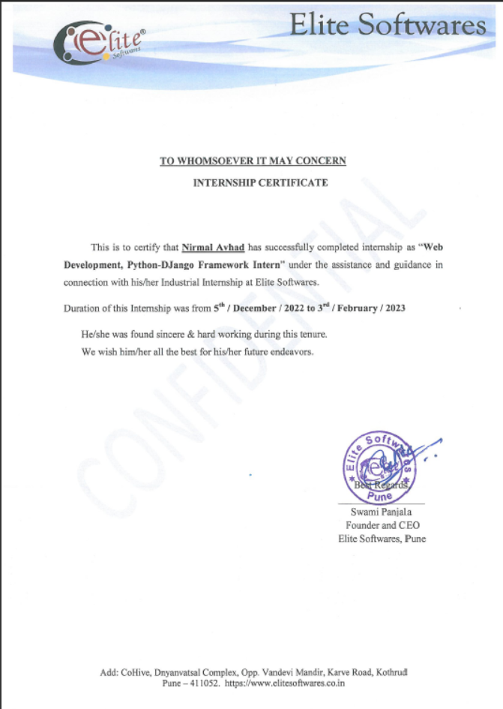

Internship Place Details

Company background-Organization | Elite Softwares
Activities/Scope | Only for School and College ERP (Enterprise Resource Planning) Software and Technical Workshops for Entrepreneurship Development
Objective of Study | - Learning web development  - Improving Python programming skills  - Gaining experience with database management  - Understanding software development life cycle  - Building a portfolio
Supervisor Details(Name,Designation,Company Name,Email_Id,Contact number) | Mr. Swami Panjala  - Founder and CEO  - swami@elitesoftwares.co.in  - 9096622683

Index

Sr. No | Chapter Name | Page No.
1 | Introduction | 6
2 | Title/Problem statement/Objective | 7
3 | Motivation/Scope and rationale of the study | 8
4 | Internship Daily Activity | 9
5 | Methodological details | 27
5 | Results/Analysis/Interferences and Conclusion | 28
7 | Suggestions | 29
8 | Attendance Record | 30
9 | Acknowledgement | 31
10 | List of references | 32
11 | Evaluation Sheet | 33

Introduction

Python-Django is a high-level web framework built in Python. Django provides a convenient way to build web applications quickly, with its clean and pragmatic design philosophy. Django follows the Model-View-Template (MVT) pattern, which is similar to the Model-View-Controller (MVC) pattern but with some differences, making it easier to develop web applications.

A Python-Django internship can be a great way to learn web development with Python, and gain hands-on experience building real-world web applications. During the internship, you are likely to learn how to set up the Django framework, including creating virtual environments, installing dependencies, and configuring database settings. You will also learn how to build web applications with Django, including creating models, views, and templates, working with URL routing, handling forms and user inputs, and integrating third-party libraries and APIs to enhance the functionality of the application.

In addition, you may also learn how to deploy a Django application to a web server, including configuring web servers, working with DNS settings, and configuring SSL certificates for secure HTTPS connections.

Throughout the internship, you will get a chance to work on real-world projects, collaborate with other developers, and receive feedback and guidance from experienced professionals. By the end of the internship, you should have a solid understanding of web development with Python-Django, and be able to build your own web applications from scratch.

Web development using Python-Django framework is a popular choice for building complex and dynamic web applications. Django is a high-level web framework that is designed to facilitate rapid development and clean, pragmatic design. Python, being a versatile and robust programming language, provides a wide range of libraries and frameworks that simplify web development.

Django provides a set of powerful tools and libraries that enable developers to build secure, scalable, and maintainable web applications. These tools include an Object-Relational Mapping (ORM) system for database management, a templating engine for rendering HTML pages, and a built-in web server for testing and debugging.

Title/Problem Statement/Objective

Title :-

Web Development Python-Django Framework

Problem Statement :-

To develop competent and skilled web developers who can build dynamic and responsive web applications using Python and Django framework, by providing hands-on training on the basics of web development, Python programming, Django framework, database management, and deployment.

Objective :-

The primary objective of the internship is to provide students with hands-on experience in web development using Python and Django. The course covers the following objectives:

•Understanding the fundamentals of Python programming language

•Understanding the Django web framework

•Developing web applications using Python and Django

•Deploying web applications to the web

Motivation/Scope & Rationale of the Study

Motivation :-

The Motivation for Web Development Python-Django Internship are designed to provide individuals hands-on experience in web development using Python and the Django framework. online developers are in high demand as businesses and organization increasingly rely on online apps for day-to-day operations. Finding experienced web developers, on the other hand, may be difficult, and our internship program tries to solve this issue by equipping individuals with the skills and knowledge needed to pursue a career in web development.

The popularity of Python and the Django framework in web development is another motivator for this internship. Python is a flexible and widely used programming language, and Django is a sophisticated web framework that makes constructing complicated web applications easier.

Scope & Rationale of the study :-

Scope

Learning the fundamentals of web development, such as HTML, CSS, and JavaScript.

Learning the Python programming language.

Comprehensive understanding of the Django framework, including the creation of views, templates, and models.

Becoming familiar with databases in web development, particularly SQL and ORM.

Using Python and the Django framework, create responsive and dynamic web applications.

Becoming familiar with the deployment and maintenance of web applications.

Rationale

Individuals will gain hands-on experience in web programming using Python and the Django framework.

To satisfy the growing need for experienced web developers across several sectors.

To provide folks the chance to learn from industry leaders and seasoned web development professionals.

To address the scarcity of qualified web developers by offering a forum for individuals to learn the skills and information required to pursue a career in web development.

To provide people the opportunity to work on real-world projects and obtain hands-on experience in web development.

To improve participants' employability and prepare them for a career in web development.

Daily Activity Report

- Day 1 :- 5th December 2022
- Topic Cover :- Domain name Creation
- Summary:-

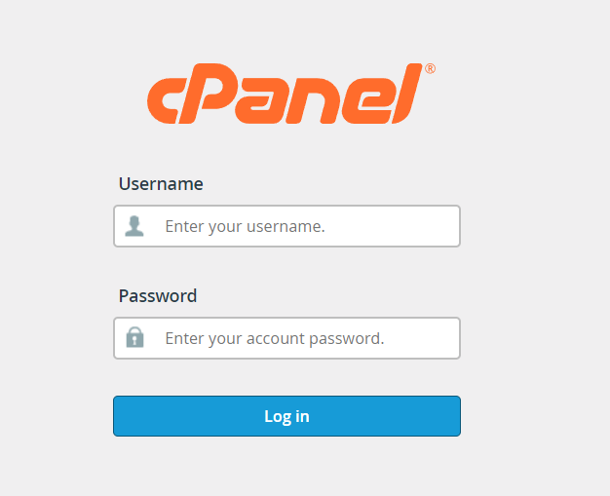
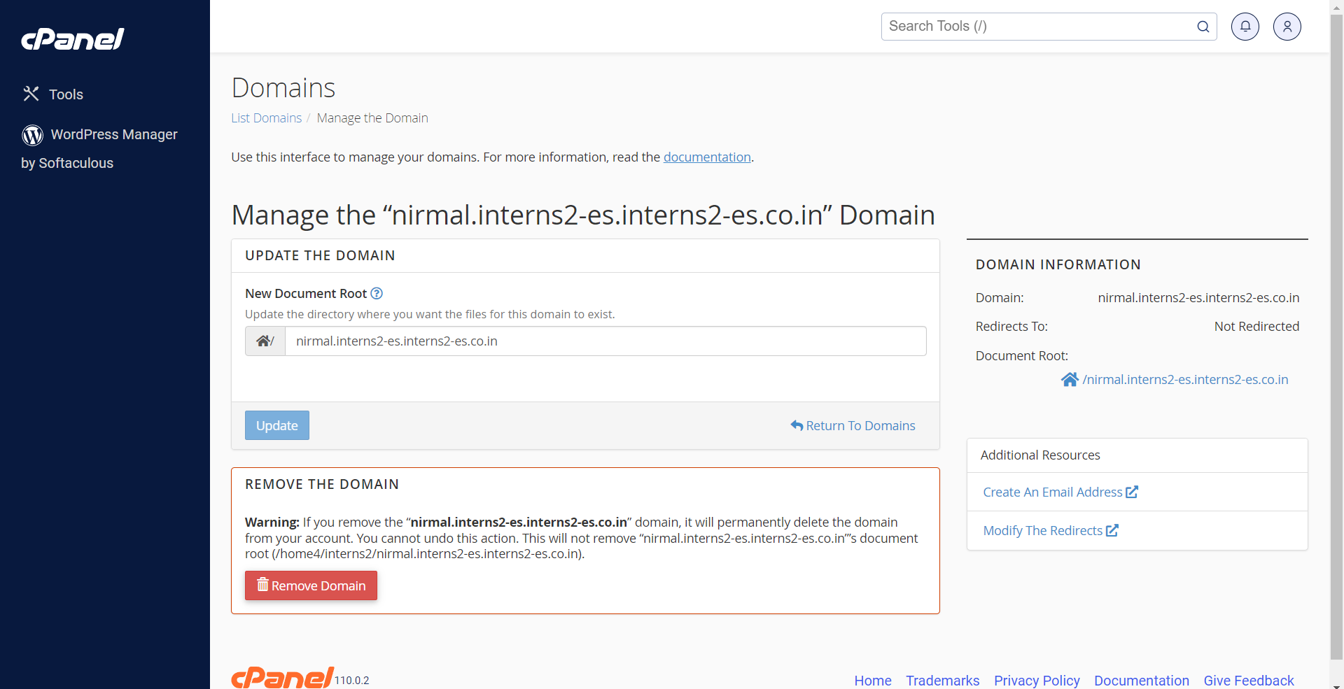

- Day 2 : 6th Dec 2022
- Topic Cover:- Python
- Summary:
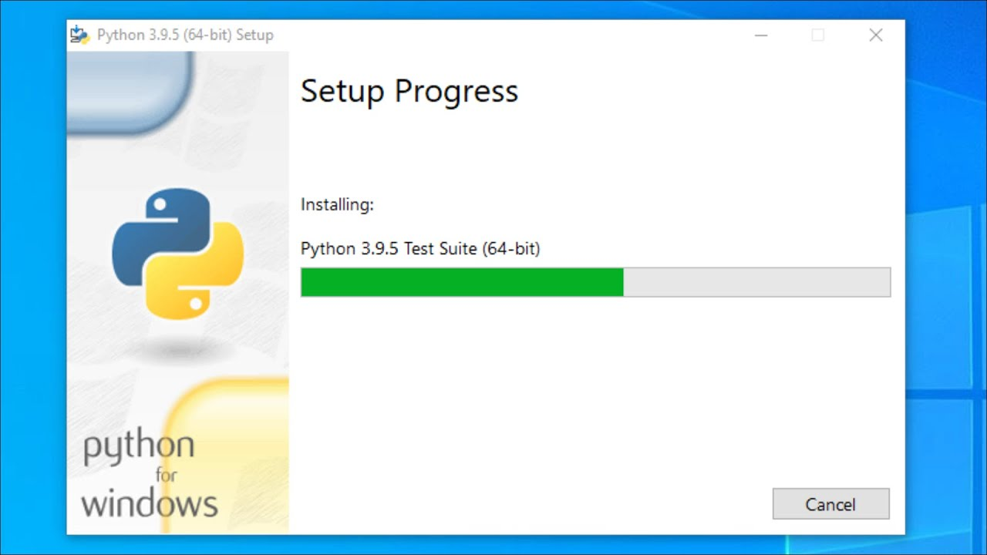
# ***Identifier*** :

# A Python identifier is a name used to identify a variable, function, class, module or other object.
name = "Hello"
A=10
b=5.5
print(name)
print(A)
print(b)

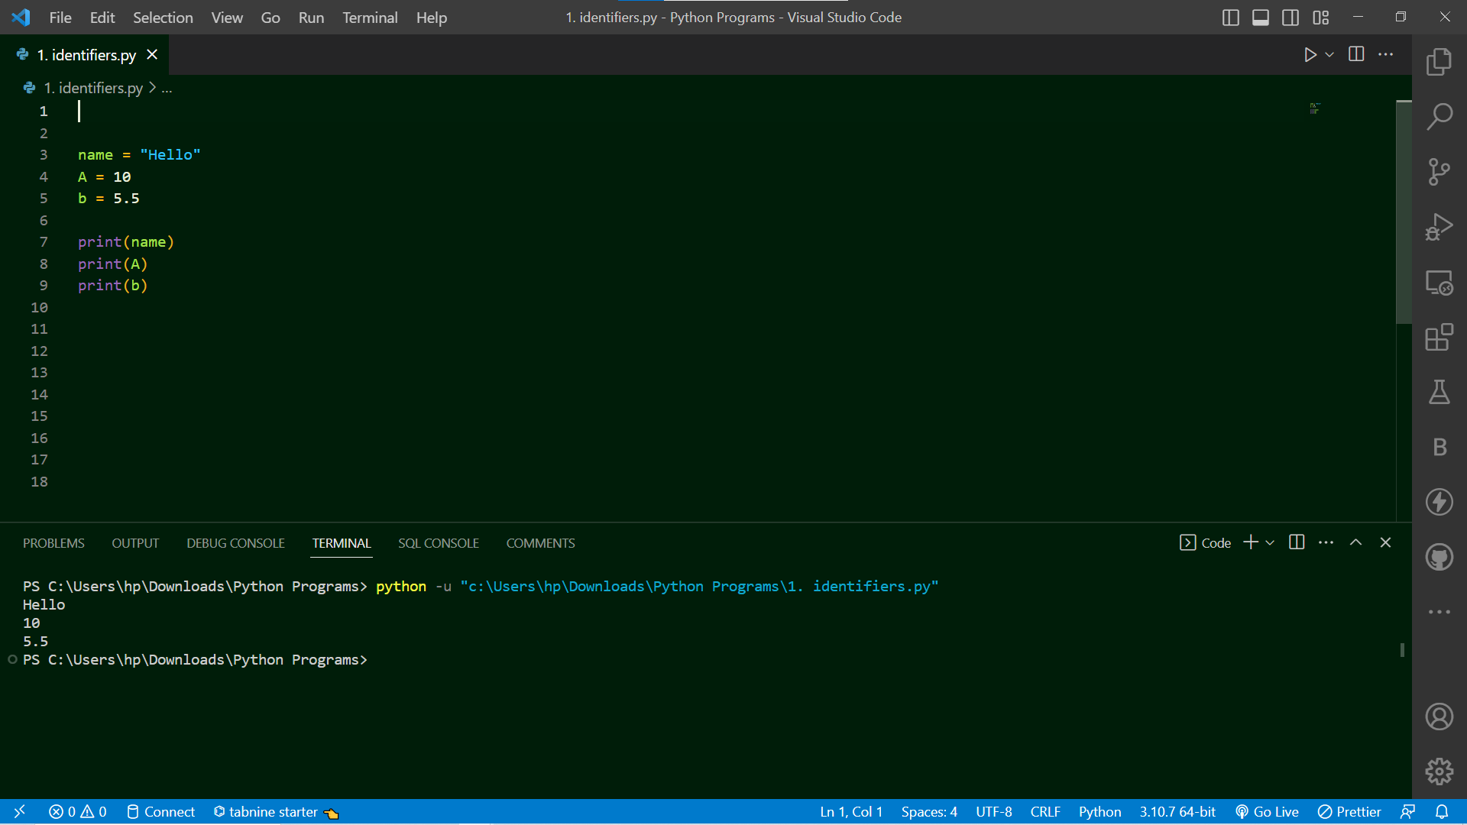

- Day 3 : 7th Dec 2022
- Topic Cover:- Variable and Data Type’s , Type casting and operator.
- Summary:
##Variable and data type’s
# Four types of literals:

# 1) String literals,
# 2) Numeric literals,
# 3) Boolean literals and
# 4) a special literal None.
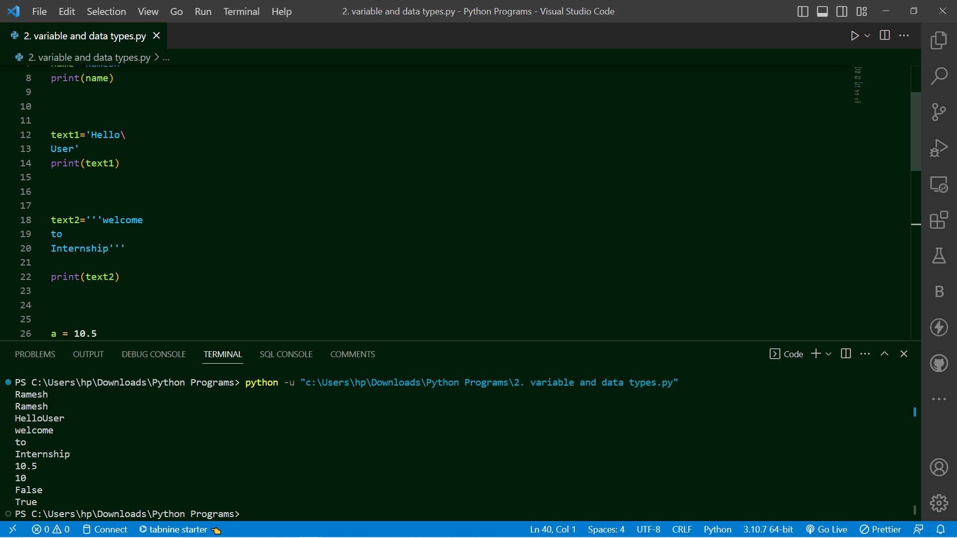
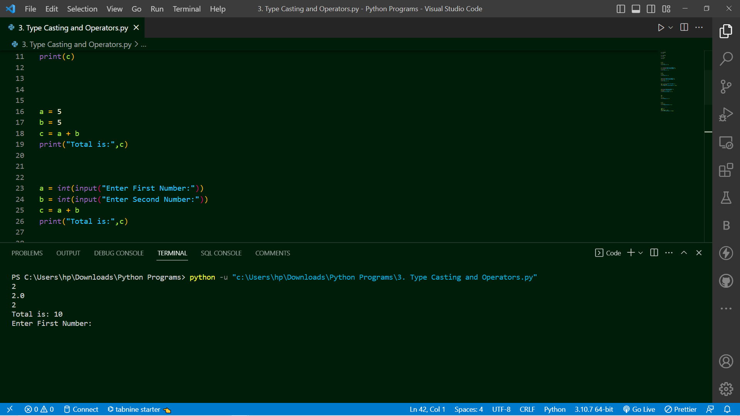

- Day 4 : 8th Dec 2022
- Topic Cover:- String and string’s method.
- Summary:
# Strings in python are surrounded by either single quotation marks, or double quotation marks.
# Python Slicing Strings:
# You can return a range of characters by using the slice syntax.
# Specify the start index and the end index, separated by a colon, to return a part of the string.
# String Methods:
- len()
- lower()
- upper()
- replace("replacing word","new word which you want replace")
- split()
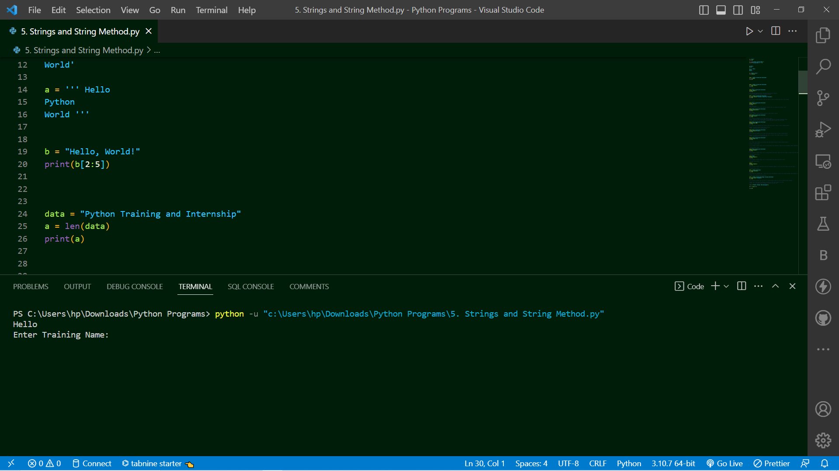

- Day 5 : 9th Dec 2022
- Topic Cover:- List in python.
- Summary:
# Python Collections : 4 Types of Collections as:
# 1) List
# 2) Tuple
# 3) Set
# 4) Dictionaries
1) List:
# Lists are used to store multiple datatypes items in a single variable.
# List items are ordered, changeable (Mutuable), and allow duplicate values.
# Lists are created using square brackets
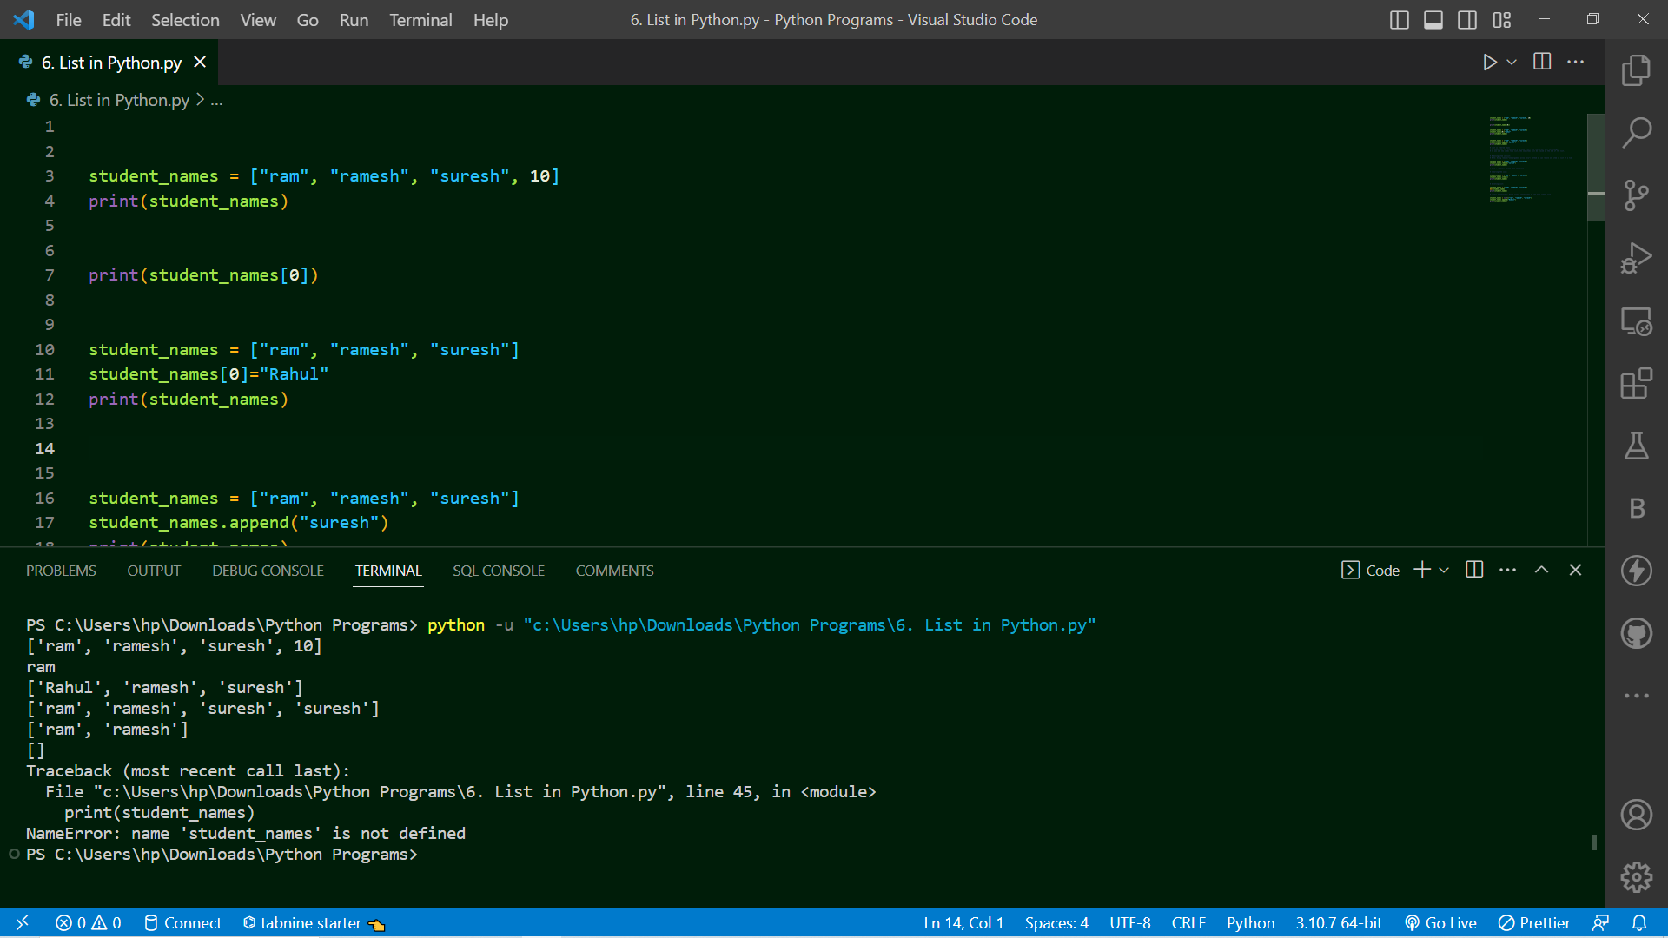

- Day 6 : 10th Dec 2022
- Topic Cover:- Tuple in python.
- Summary:
# 2) Tuple:
# Tuples are used to store multiple datatypes items in a single variable.
# tuple items are ordered, immutable (un-changeable), and allow duplicate values.
# tuple are created using round brackets (or also called paranthesis)

student_names = ("ram", "ramesh", "suresh")
print(student_names)

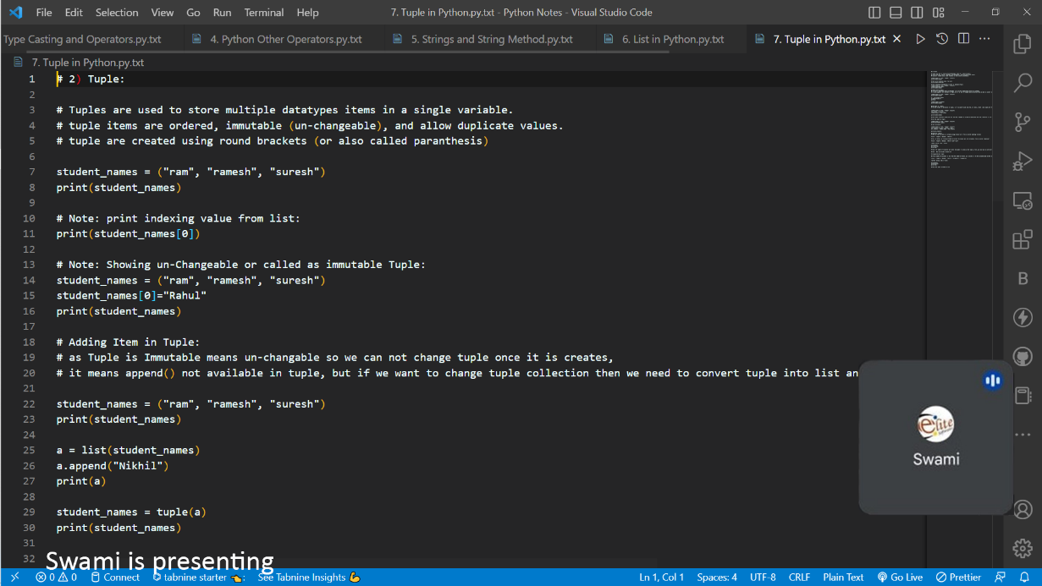

- Day 7: 12th Dec 2022
- Topic Cover:- Sets in python.
- Summary:
# 3) Set:

# Set is a collection which is un-ordered,
# Set is un-changeble, un-indexed and do not allow duplicate value
# set are created using curly braces { }

# Un-ordered Set collection

student_names = {"ram", "ramesh", "suresh"}
print(student_names)
# Un-changeble - Immutable Set collection

student_names = {"ram", "ramesh", "suresh"}
student_names[0]="rahul"
print(student_names)

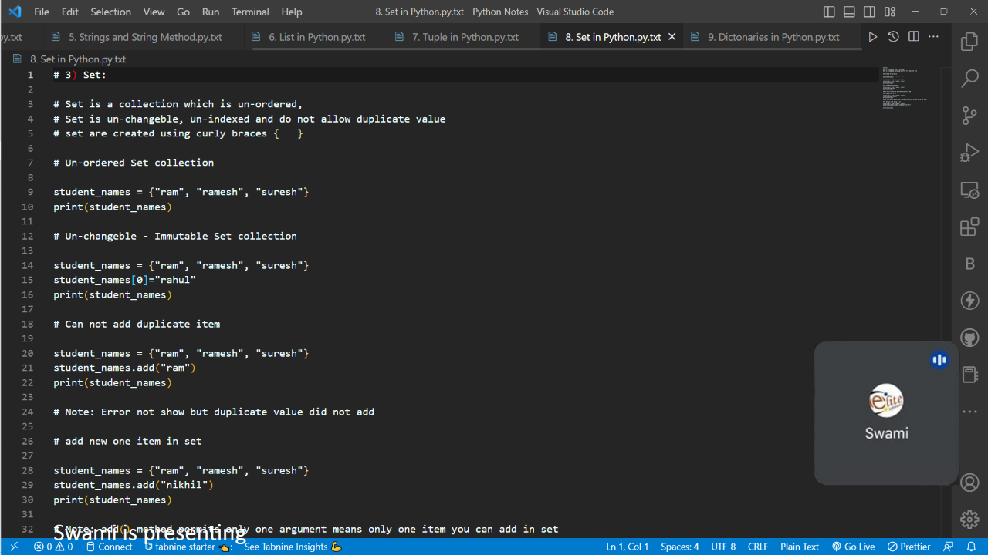

- Day 8: 13th Dec 2022
- Topic Cover:- Dictonary in python.
- Summary:
# 4) Dictonaries:
# Dictionary is a collection which is ordered,
# dictionary items are changeable and do not allow duplicates.
# dictionary are created using curly braces { }
# Dictionaries are used to store data values in key:value pairs "" : ""
# Note : As of Python version 3.7, dictionaries are ordered. In Python 3.6 and earlier, dictionaries are un-ordered.
# Create and print a dictionary:
mobile = {
"brand":"apple",
"model":"iphone12",
"Year":"2022",
}
print(mobile)

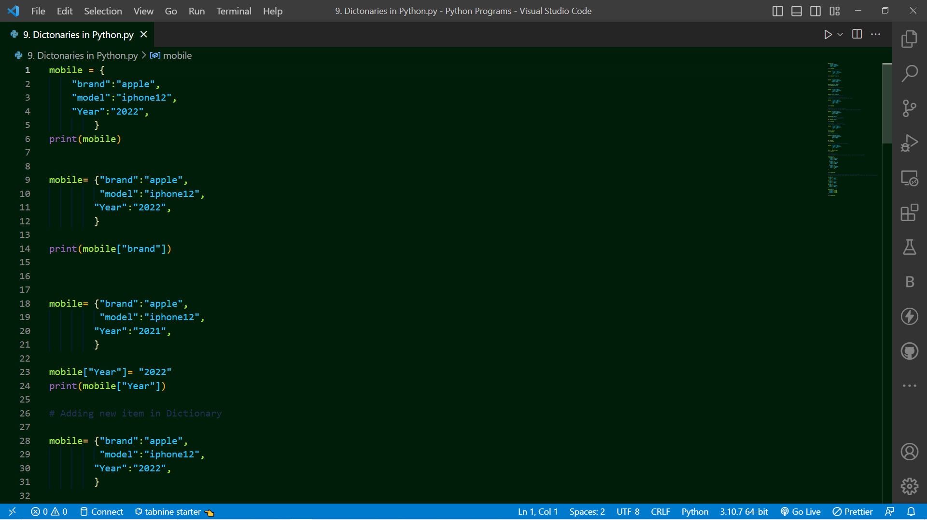

- Day 9: 14th Dec 2022
- Topic Cover:- Python condition and if statement
- Summary:
# Python supports the usual logical conditions from mathematics:

# Equals: a == b
# Not Equals: a != b
# Less than: a < b
# Less than or equal to: a <= b
# Greater than: a > b
# Greater than or equal to: a >= b

# These conditions can be used in several ways, most commonly in "if statements" and loops.
# "if statement" is written by using the if keyword.

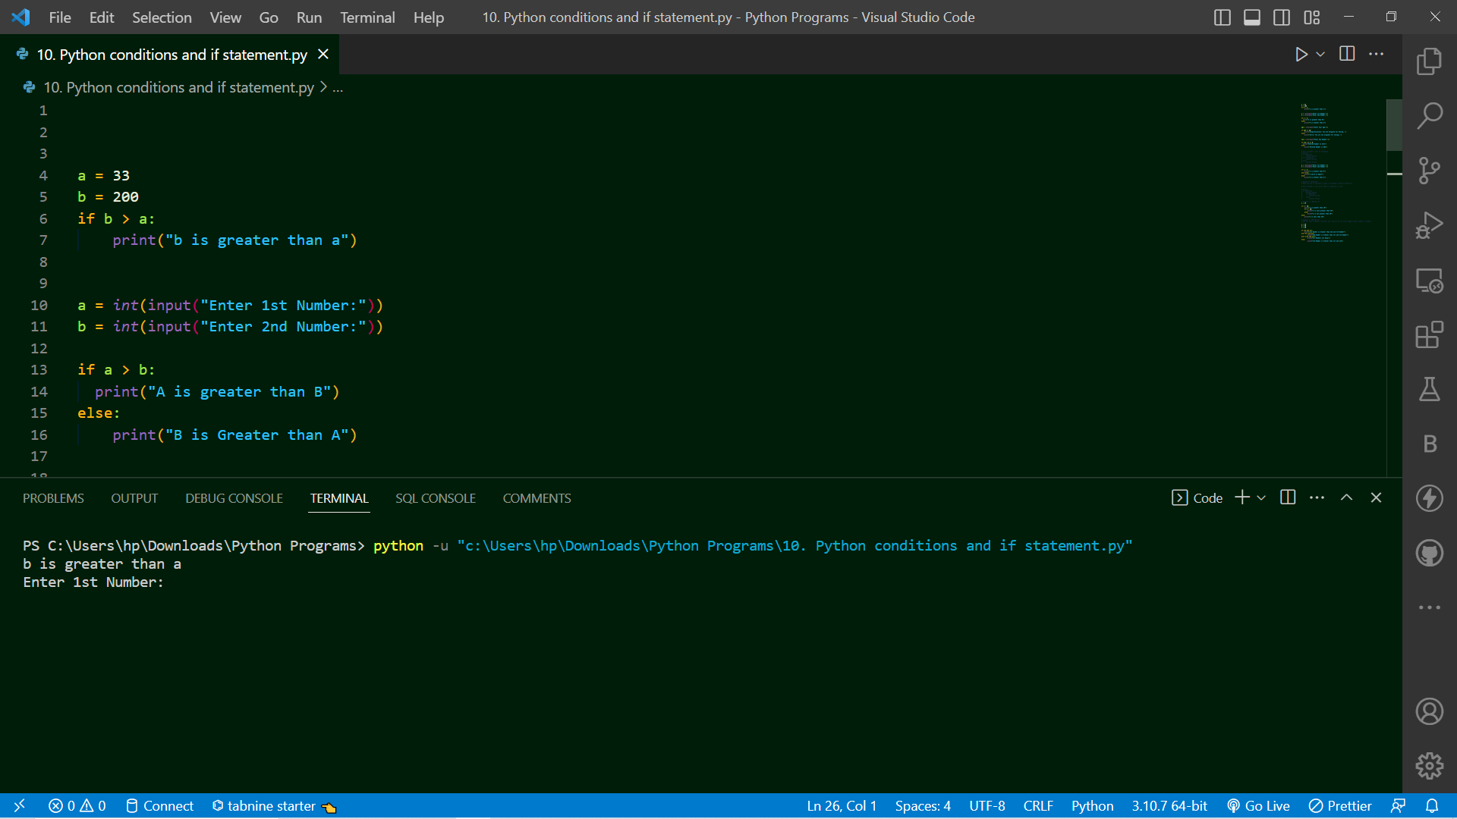

- Day 10: 15th Dec 2022
- Topic Cover:- Loops in python and function in python
- Summary:
1)
# Looping Statement : While Loop and For Loop
# excecute block of statements till condition is false
# While Loop
a = 1
while a <= 10:
print(a)
a += 1
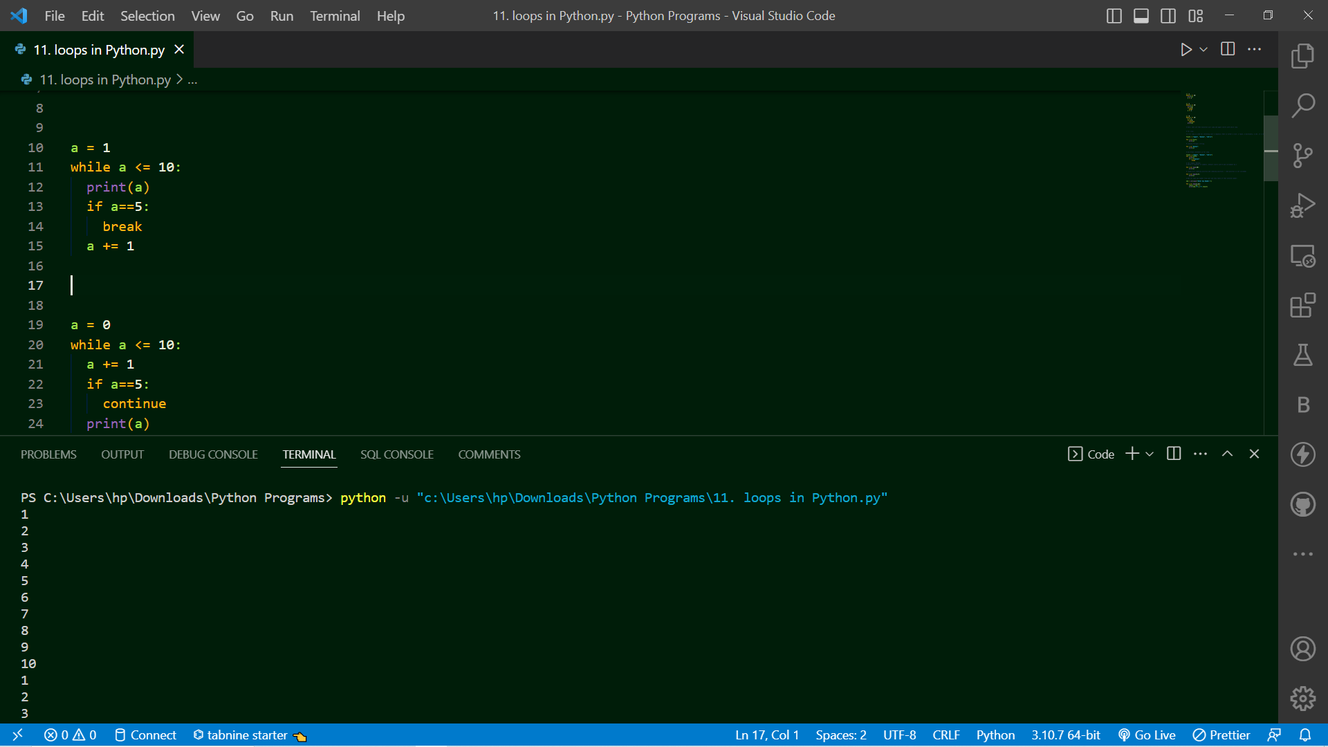

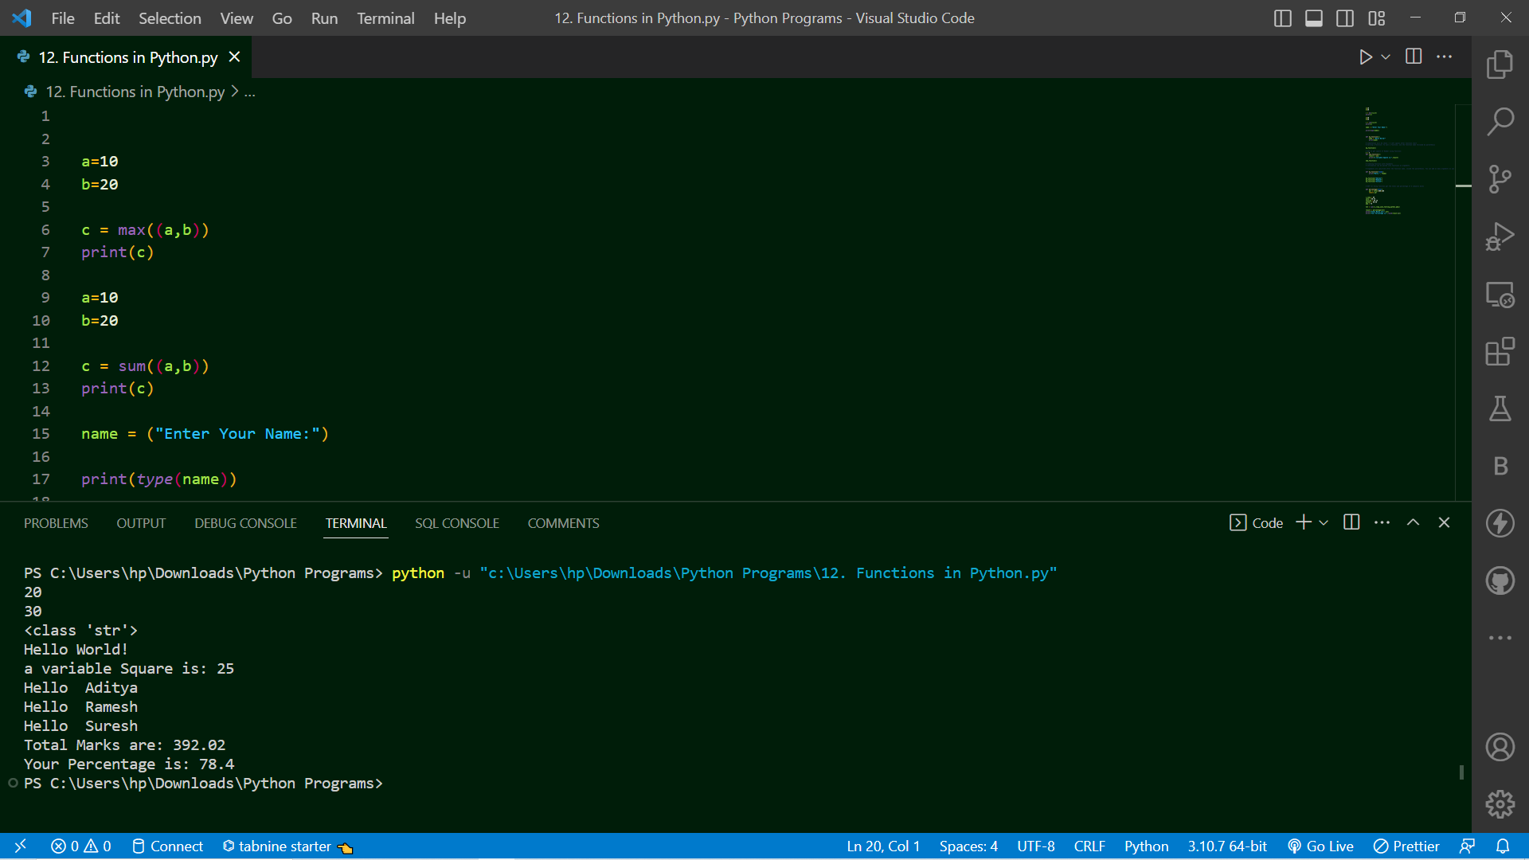
- Day 11: 16th Dec 2022
- Topic Cover:- Lambda function in python and python module
- Summary:
1)
# A lambda function is a small called as one line or anonymous function.
# A lambda function can take any number of arguments, but can only have one expression.

# Syntax : lambda arguments : expression

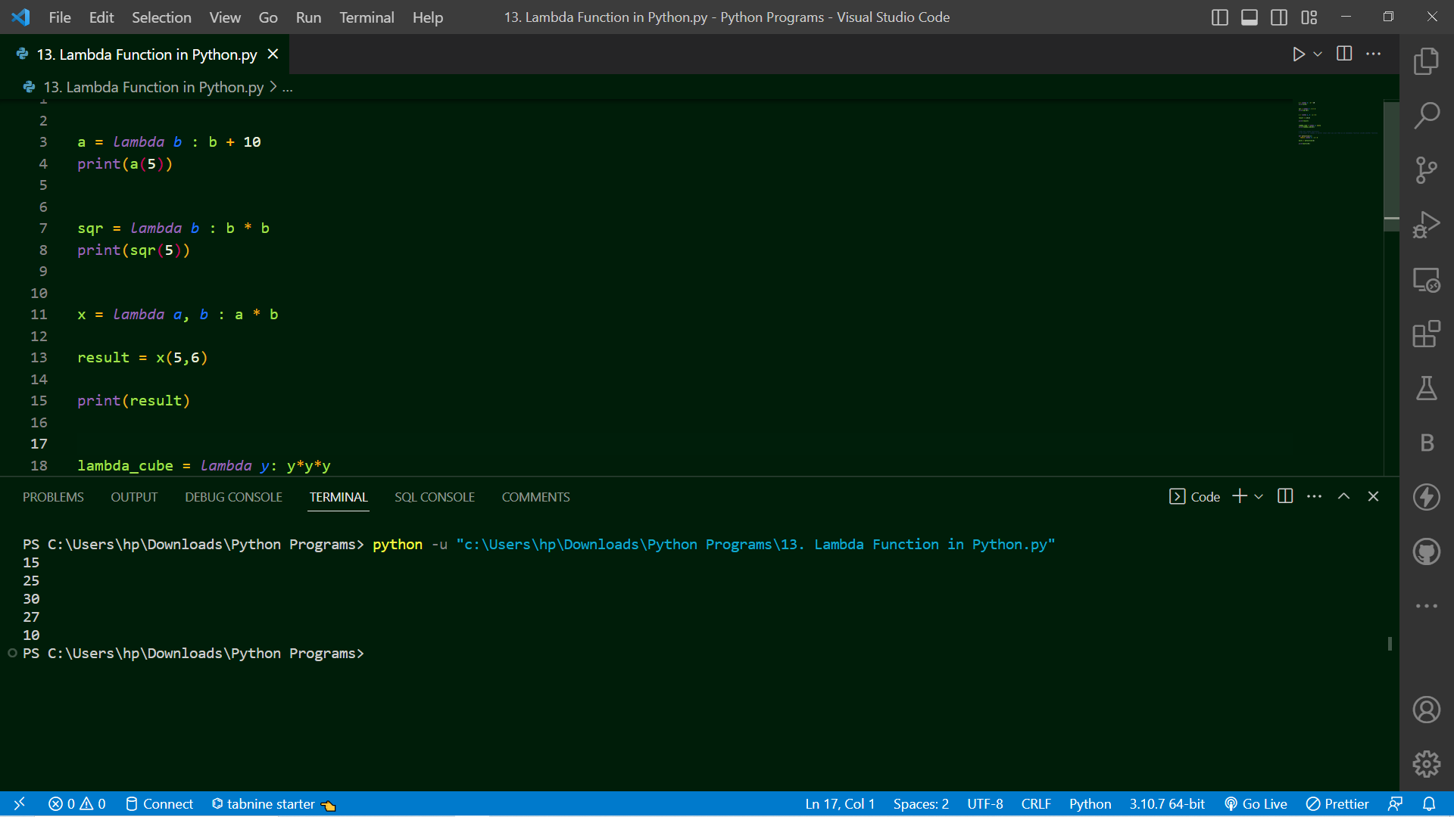
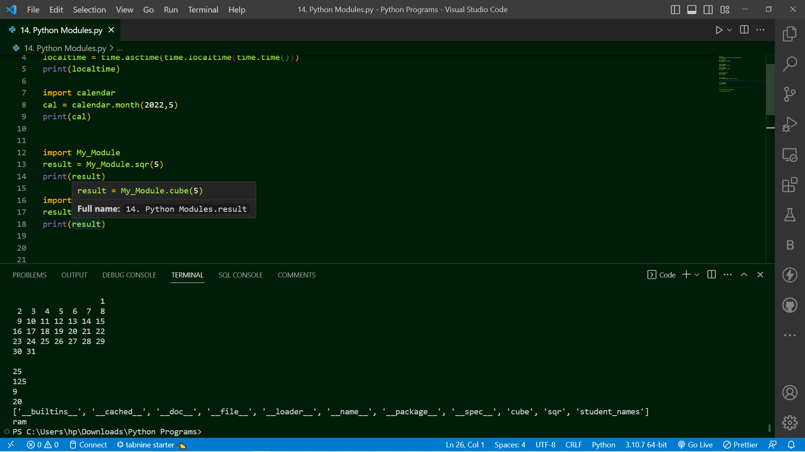

- Day 12: 17th Dec 2022
- Topic Cover:- File Handling and OOP’s Concept
- Summary:
# File Handling in Python:
# File handling is an very important part of any web application.
# Python has several functions for creating, reading, updating, and deleting files.
# Two Types of Files :
# 1) Text Files (Ex. .txt) represent as "t"
# 2) Binary Files (Ex. .jpg, .dat) represent as "b"
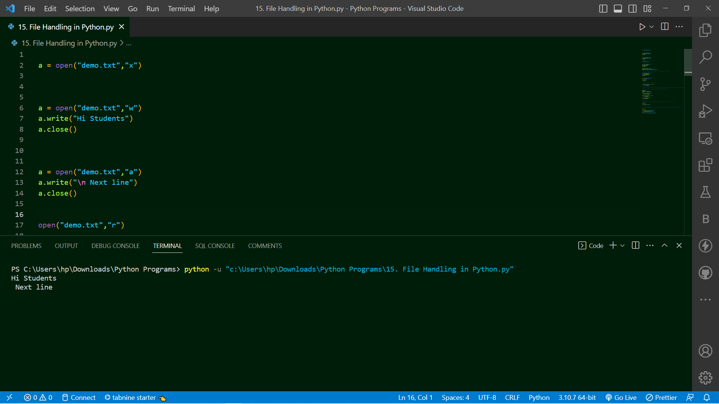
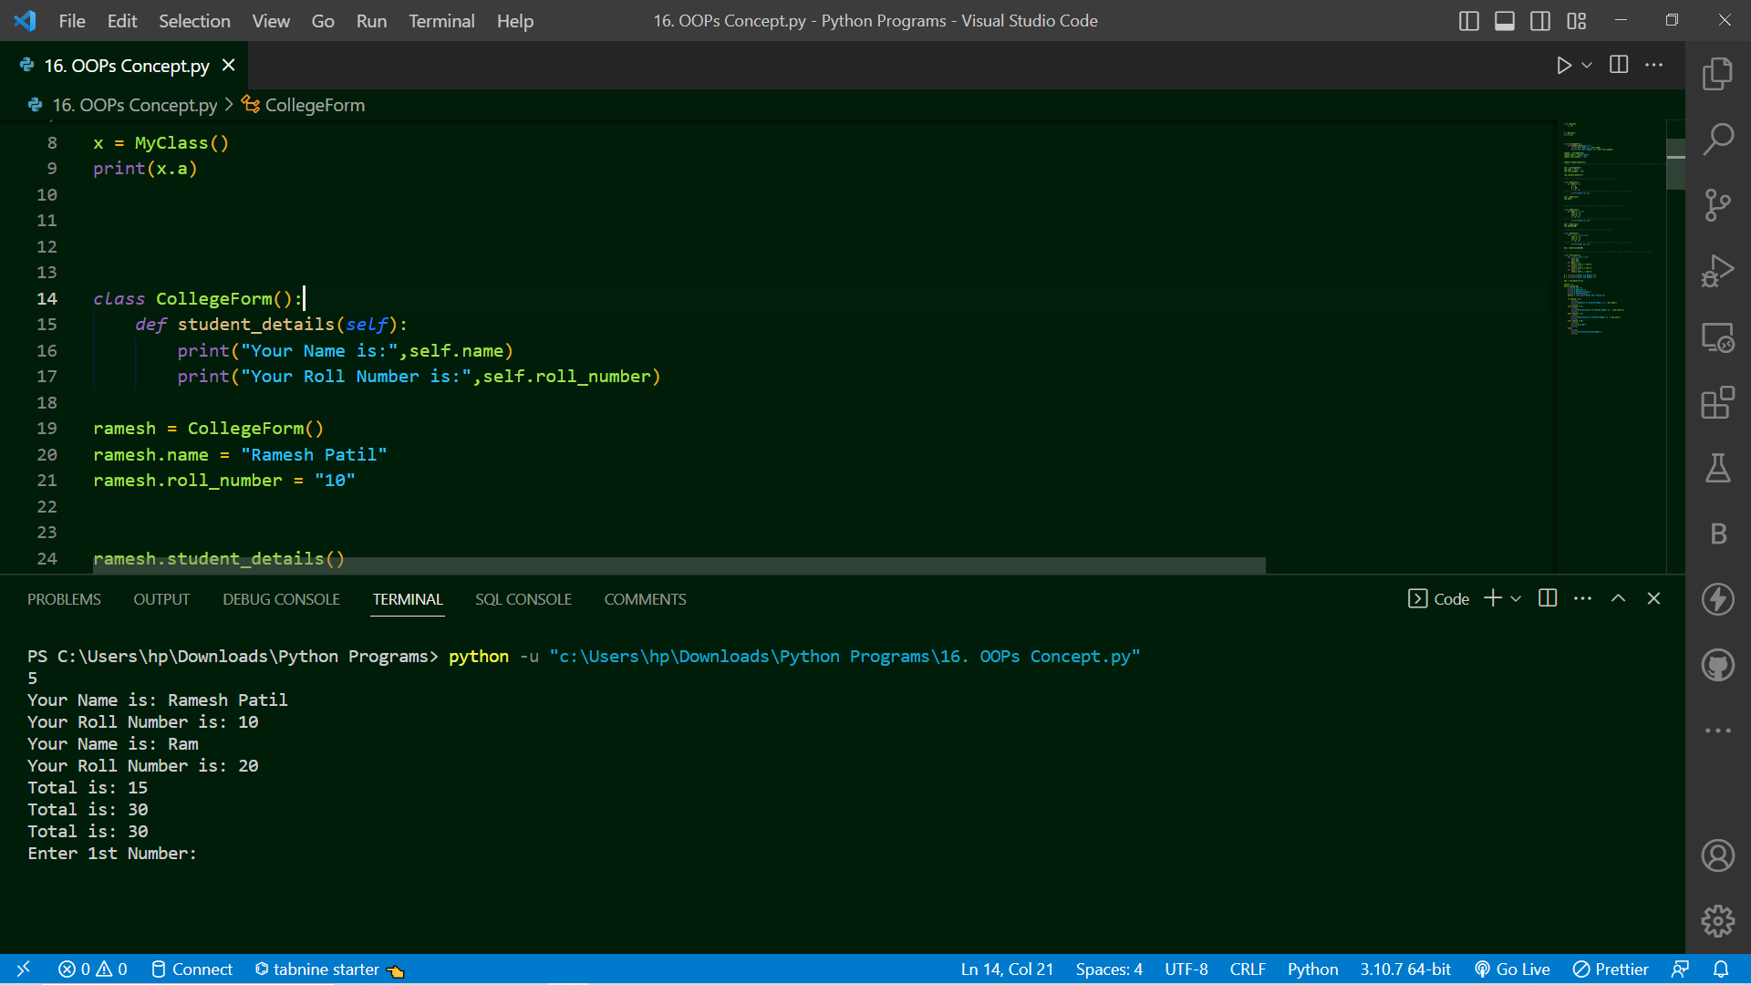

- Day 13: 19th Dec 2022
- Topic Cover:- SQLite database create using database and creating ,inserting data into table
- Summary:
1)
# Python SQLite3 module is used to integrate the SQLite database with Python.

# Using SQLite3 Module you can perform all possible DB operations like creating database, creating table and performing various operations on table.
Connecting SQLite Database through Python:

# As mention using SQLite3 module we can integrate SQLite Database therefore as we import any module similarly we can import sqlite3 module in our program and can connect sqlite database through python.

import sqlite3
# compulsory we need to import sqlite3 module for performing databse related operations.

con = sqlite3.connect("test.db")
# con is connection_object for database

2)
# Creating table using Python:
import sqlite3
con = sqlite3.connect("test.db")

cur = con.cursor()
# Cursor() is a class which having methods like execute(), fetchall(), fetchmany(), fetchone(), etc. and if we want to access cursor class methods therefore we need to create object of cursor class and then only we can call methods under cursor() class
cur is the object of cursor

- Day 14: 22th Dec 2022
- Topic Cover:- Getting started with Django and creating first project
- Summary:
Django is a Framework of Python - so we Required Python software in our system
# search on google - download python and open python.org.download link and download latest version and install

# While installation - tick mark all check boxes while installation, click to custom installation and tick mark all check boxes and next next
Using PIP install django
# command we can install django framework

# django-admin --version
# we can check installed django version

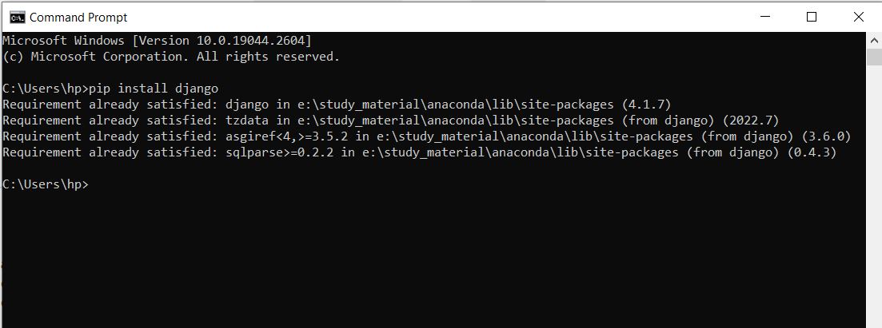

Creating project of name First_Project using terminal:

django-admin startproject Project_name

# if showing "django-admin" not recognized internal or external command - error
# then we need to run below command:

python -m django startproject Project_name

# Note : underscore _ is allowed in Project Name as Prject_MIT

# Note : Project Name does not allowed : spaces as Project College, - as Project-College, digits before name as 123Project not allowed

Project1
# manage.py
# Project1/
# __init__.py
# asgi.py
# settings.py
# urls.py
# wsgi.py

# These are default files and folder which created by django framework

# Run the Django Project on Browser before that you need to enter in that project Name using:
# On Terminal type :
cd Project_Name

# and then you can run project
# On Terminal type :
python manage.py runserver
or
py manage.py runserver
or
python3 manage.py runserver
# Python excute and start server and gives you ip address to see output

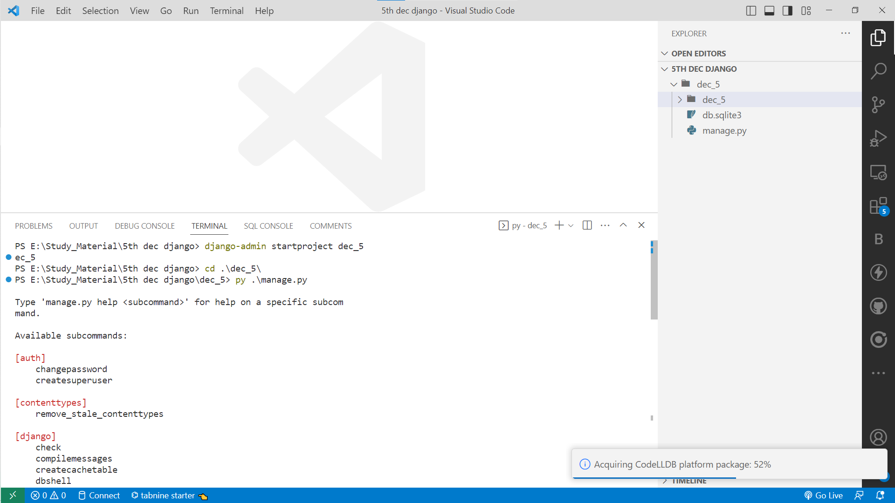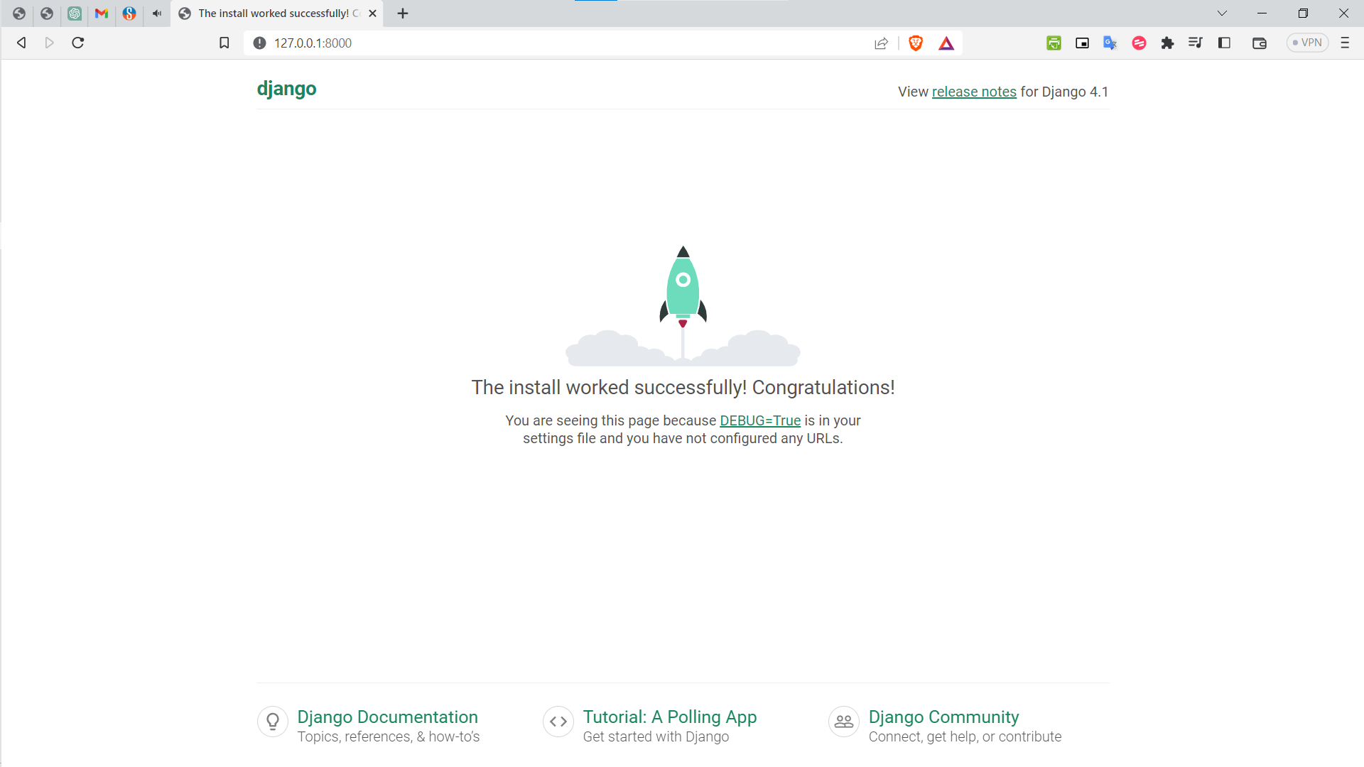

- Day 15: 23th Dec 2022
- Topic Cover:- 3. Create App and urls dispatcher
- Summary:
What is an App?
# An app is Web Application use to create different task like website app for complete Website as Home Page, About Us Page, Contact Us Page, etc, a contact form, or website blog, or any other application which you want to run seperately.
# Minimum 1 app you need to create to run web application
# Create App (Module) in your Project:
# Will give name to app as website
# In the Terminal type:
py manage.py startapp website

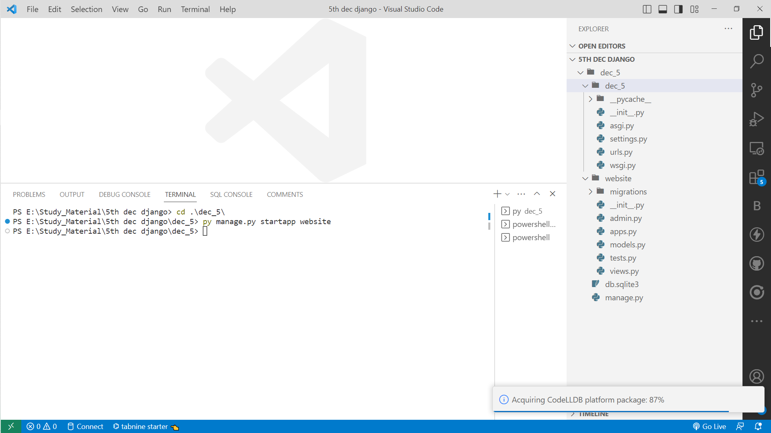
Note : Remember one thing you need to create urls.py file in the same Home app as MVT Architecture says through urls.py only it will moves to views.py and then model(if form or table required) and template (UI Design)

# Therefore Compulsory create urls.py file in your newly created app and from urls page redirect to views.py page where functions are available for redirect path.

# When we create Project, default project name one default app is created, where settings.py
# file is available, which is the Project Setting file, all project related settings you need to write in this settings.py file

# Copy urls.py from default project app and create in Home app which is our
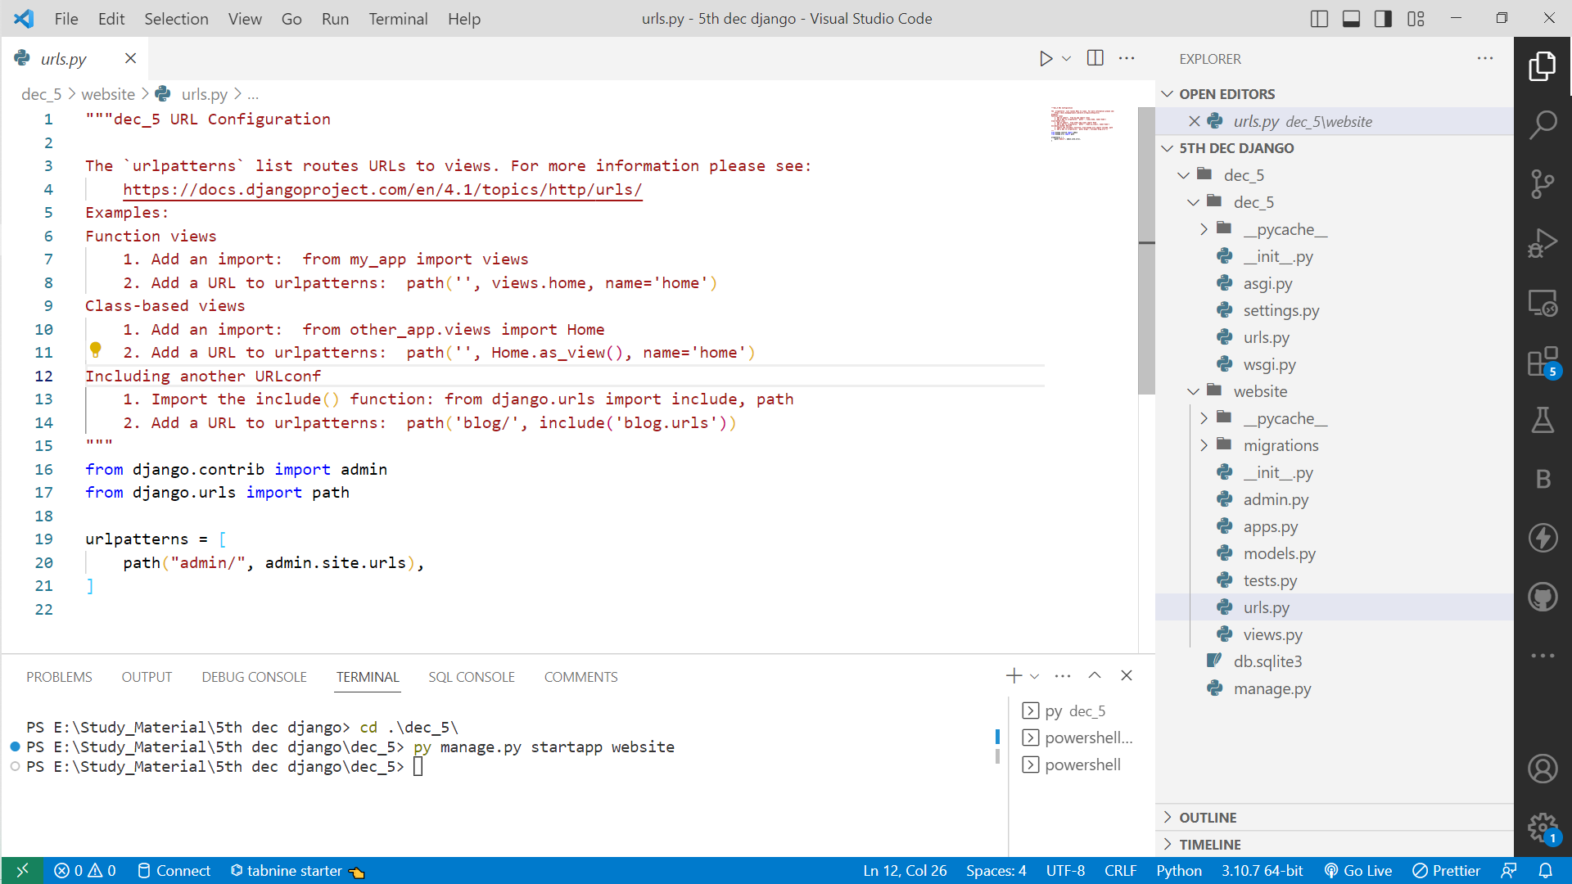

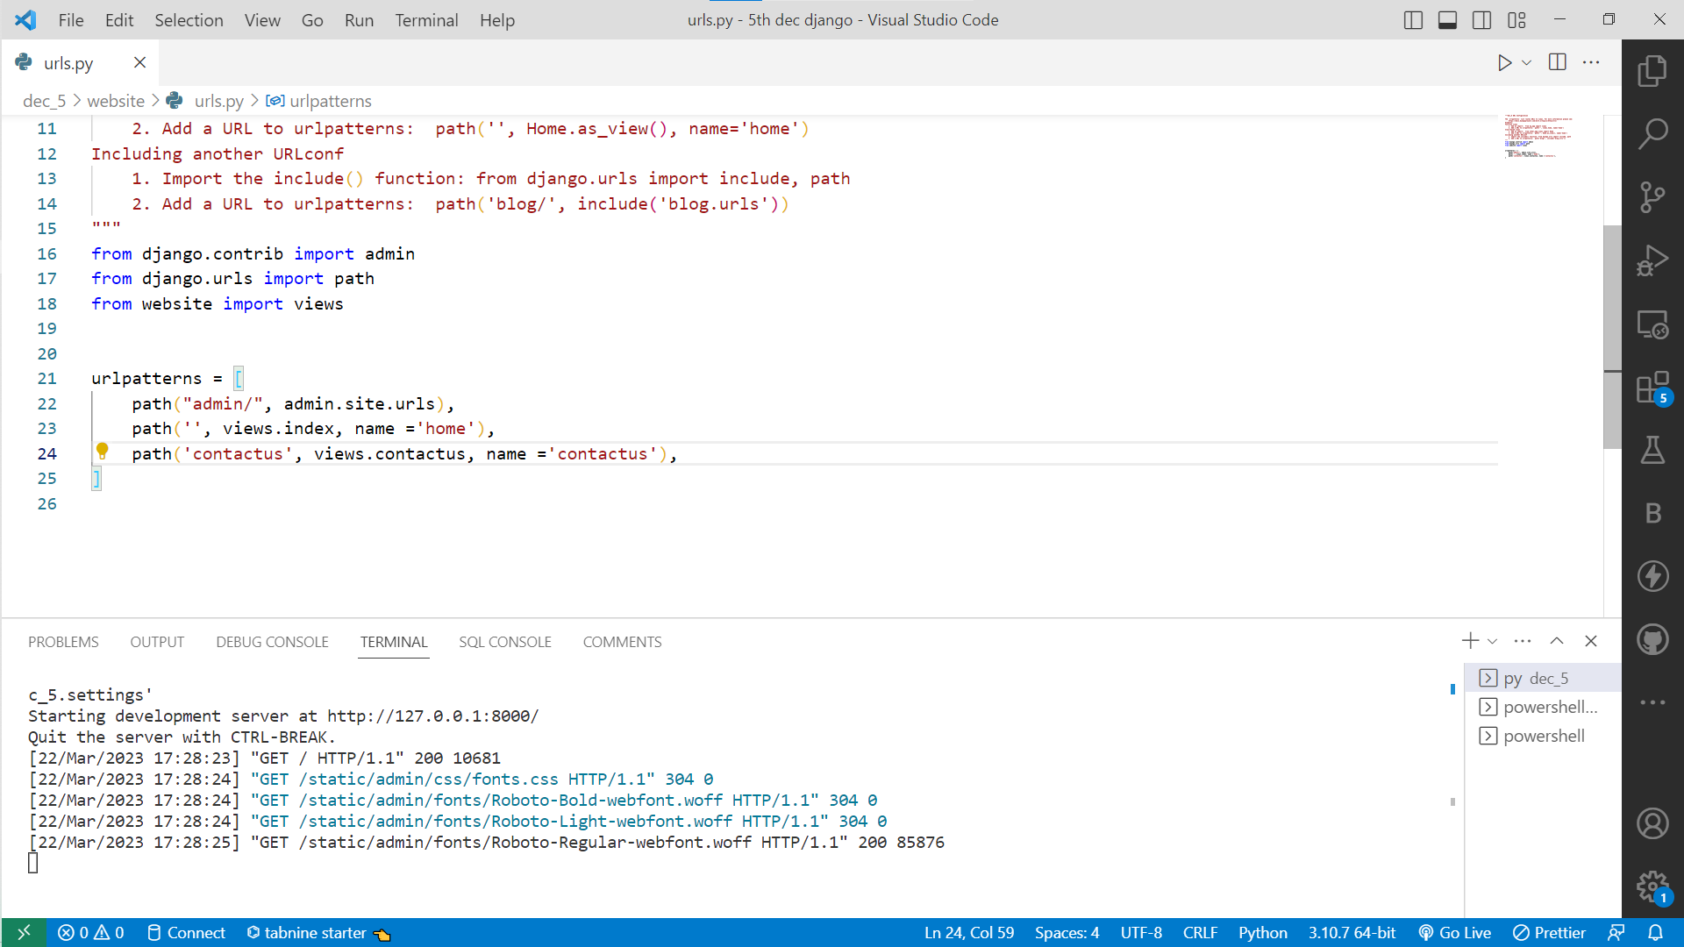
As we are using include() therefore include module we need to import
path('', include('website.urls'))
# Above path() meaning when blank path got from browser example - www.abc.com - then it should be redirect to Home.urls page
# Home (is our created app)

Methodological Details

Needs Assessment: The program begins with a needs assessment to determine the participants' learning requirements and objectives. A pre-internship survey and individual interviews with participants are used to determine their expectations, aspirations, and past knowledge.

The theoretical lectures: that address the principles of web development, Python programming, and the Django framework. These workshops are led by expert trainers who employ a variety of instructional techniques, including lectures, demonstrations, and interactive discussions. The workshops give learners a thorough foundation of web development concepts and techniques, as well as the Django framework.

Practical tasks: The program contains practical tasks that allow learners to apply what they've learned in the classroom to real-world settings. The tasks are intended to reinforce theoretical principles while also providing practical experience with Python and the Django framework. Depending on the nature of the task, the assignments are performed either independently or in groups.

Hands-on Projects: The program includes hands-on projects that provide learners the opportunity to work on real-world web development projects. The projects are meant to imitate real-world problems and allow participants to apply their knowledge in a practical environment. Depending on the nature of the project, projects are performed either alone or in groups.

Mentorship & Support: Throughout the internship, participants will get mentorship and support from the program. Each participant is allocated a mentor who will provide direction, support, and feedback on their assignments and projects. Participants can also ask trainers and mentors for help via email, online forums, or one-on-one meetings.

Assessment and Evaluation: The program includes assessments and evaluations to track learning outcomes and internship effectiveness. Practical assignments, hands-on projects, and online quizzes are used to assess participants. The assessments are carried out using feedback questionnaires and participant interviews to identify the program's strengths and flaws as well as possibilities for development.

Result/Analysis/Conclusion

Result

Participants will have gained knowledge of web development, Python programming, and the Django framework. They will be able to develop and deploy responsive web apps in real-world settings using Python and Django. Participants will have a comprehensive overview of the web development industry, including the most recent trends, technologies, and best practices . They will have gained information from industry experts and seasoned professionals, which they will be able to utilize in their future careers.

Participants will have created a portfolio of projects that exhibit their web development abilities and expertise. This portfolio may be used to show potential employers their talents.The participants' network of connections in the web development business will have grown. This network may be used to obtain jobs, get advice, and cooperate on future initiatives. Participants will be better equipped to pursue a profession in web development. They will have obtained hands-on experience and industry understanding, as well as the skills and portfolio required to excel in the sector.

Analysis

The Web Development Python-Django Internship program is intended to offer participants with practical knowledge and abilities in web development using the Python programming language and the Django framework. This program aims to provide learners with the skills and knowledge needed to pursue a career in web development. The internship program's methodology involves offering training materials, hands-on projects, collaborative learning, learning from industry experts, internship assessment, and networking opportunities. This strategy seeks to give participants with a full and practical learning experience. The internship program results in improved skills, industry knowledge, a portfolio of projects, networking opportunities, and job preparedness. These results may help participants to pursue a successful career in web development and contribute to the industry's growth.

Conclusion

The Web Development Python-Django Internship provides students with hands-on experience in web development using Python and Django. With an increasing need for web developers, this internship can assist students in laying a solid basis for a future in web development or a related sector. Students will have the knowledge and abilities needed to create and deploy web applications using Python and Django by the conclusion of the internship.

Suggestions

Establish Specific Goals and Objectives: Establish specific goals and objectives for the internship program and convey them to participants. This will assist students in understanding what is expected of them and what they may anticipate from the program.

Provide a Planned Curriculum: Provide a structured curriculum covering the fundamentals of web development, Python programming, and the Django framework. This ensures that participants have a firm foundation of knowledge and skills upon which to expand.

Encourage Collaboration: Encourage people to work on projects and activities together. This will allow them to learn from one another, share ideas, and improve their collaboration abilities.

Provide Feedback Opportunities: Give participants regular feedback on their progress and constructive criticism to help them develop their abilities. This will keep them motivated and focused on their objectives.

Mentorship: Provide mentorship to participants from experienced individuals in the field of web development. This will give students with career counselling, assistance, and industry insights that will help them succeed.

Encourage Networking: Encourage participants to network with other web development experts. Attending business events, participating in online forums, and engaging in social media activities are all ways to do this.

Attendance Record

Sr.No. | Date | Company Supervisor Sign
1 | 5 Dec 22 -8 Dec 22
2 | 9 Dec 22 - 12 Dec 22
3 | 13 Dec 22 - 16 Dec 22
4 | 17 Dec 22 - 20 Dec 22
5 | 21 Dec 22 - 24 Dec 22
6 | 25 Dec 23 - 28 Dec 23
7 | 29 Dec 23 - 31 Dec 23
8 | 23 Jan 23 - 26 Jan 23
9 | 27 Jan 23 - 31 Jan 23
10 | 1 Feb 23 - 3 Feb 23

Acknowledgment

It is our pleasure to acknowledge sense of gratitude to all those who helped us in completion of Internship. I am highly indebted to Mrs. Rasika K Mam from DYPIEMR, Akurdi & Mr. Swami Panjala for their guidance and constant supervision as well as for providing necessary information regarding the internship & also for their support.
I would like to express my gratitude towards Mrs. Suvarna Patil (Head - Department of AIDS) for their kind co-operation and encouragement which help me for providing the required facilities.

Finally we wish to thank and appreciate to all our teachers and friends for their constructive comments, suggestions and guidance and all those directly or indirectly helped us in completing this internship.

List of References

- https://www.python.org/downloads/
- https://www.djangoproject.com/
- https://realpython.com/tutorials/web-dev/
- https://cpanel.net/
- https://bootstrapstudio.io/

Evaluation Sheet

Sr No. | Evaluation Parameters | Marks
1 | Attendance Record(Out of 25)
2 | Diary/Workbook(Out of 25)

Signature of Internal Internship Supervisor Signature of External Internship Supervisor

